**YOUTUBE SPAM DETECTION: LEVERAGING ENSEMBLE ALGORITHMS FOR ROBUST FILTERING**

**ABSTRACT:**

The ever-growing popularity of YouTube has brought with it a deluge of unwelcome guests: spam comments. These disruptive messages not only detract from user experience but also stifle genuine conversation. While YouTube employs its own filtering system, it often falls short in completely eradicating the problem.

This research proposes a novel approach to combating YouTube spam – leveraging the power of ensemble learning. We delve into existing studies on YouTube spam detection and conduct a series of classification experiments. Five individual machine learning algorithms are put to the test: Decision Tree, Logistic Regression, Random Forest, Support Vector Machine, Extra Tree Classifier. Additionally, we explore the potential of two ensemble models: Ensemble with Hard Voting and Ensemble with Soft Voting. These models combine the strengths of individual algorithms, aiming to achieve a superior level of spam detection accuracy.

To comprehensively evaluate these techniques, we train them on a dataset of comments from popular music videos by renowned artists. By harnessing the capabilities of machine learning and ensemble approaches, this research aims to develop a robust system for filtering YouTube spam comments, fostering a more positive and engaging online platform for users.

**CHAPTER 1**

**INTRODUCTION**

* 1. **OBJECTIVE:**

In the ongoing fight against spam, machine learning algorithms like Random Forest and Support Vector Machines have emerged as sophisticated tools. These techniques excel at distinguishing spam from legitimate emails due to several key strengths. Firstly, they can effortlessly handle massive datasets, a critical requirement considering the ever-expanding volume of email traffic. This scalability ensures the spam filter remains effective as email usage continues to grow. Secondly, these algorithms are resistant to overfitting, a common pitfall where a model memorizes the training data too well and struggles with new emails. This robustness prevents the filter from becoming outdated as spammers employ new tactics. Perhaps most importantly, these algorithms offer interpretability, the ability to explain their classifications. This transparency is essential for building trust in the system and for ongoing improvement. By strategically combining the strengths of multiple decision trees, these algorithms can uncover intricate and nuanced patterns within emails that are hallmarks of spam content. This leads to highly accurate spam filtering, protecting users from unwanted and potentially malicious emails. Furthermore, the insights gleaned from these algorithms can be used to continuously refine the spam filter, ensuring it stays ahead of evolving spammer techniques.

These same principles can be applied to tackle spam comments on YouTube videos. The leveraging pre-trained machine learning model, similar to those used for email spam detection, to analyze comments on YouTube videos. This model will be trained on a vast dataset of labeled YouTube comments, allowing it to distinguish between genuine discussion and spam. By focusing on the YouTube ecosystem, we can tailor the model to identify patterns specific to spam comments on this platform. This user-driven approach empowers viewers to analyze comments on any YouTube video and gain a clearer picture of the comment section. The project aims to reduce the prevalence of spam comments, fostering a more informative and engaging environment for the YouTube community.

* 1. **Problem Statement**

The phenomenal growth of YouTube has unfortunately attracted a surge of malicious actors. Spam comments disrupt user experience by flooding comment sections with irrelevant promotional content, phishing attempts, and other security risks. While YouTube employs a filtering system to mitigate this issue, it faces significant limitations:

* Static Rule Vulnerability: The current filter relies on pre-defined rules, making it susceptible to evolving spam tactics. As spammers employ more sophisticated techniques and obfuscate messages, the filter's effectiveness diminishes.
* Inaccurate Detection: Strict filtering rules can lead to false positives, inadvertently removing legitimate comments that contain keywords or phrases commonly associated with spam. This frustrates users attempting genuine conversation.
* Lack of Transparency: The filtering process remains opaque to users. When comments are flagged as spam, there's minimal explanation provided, hindering trust and user understanding.

These limitations highlight the critical need for a more robust and adaptable approach to tackling YouTube spam comments. This project aims to address this challenge by proposing a novel solution.

* 1. **SCOPE OF PROJECT:**

The “**YOUTUBE SPAM DETECTION: LEVERAGING ENSEMBLE ALGORITHMS FOR ROBUST FILTERING”** project focuses on developing a web application specifically designed to address spam comments on YouTube videos. While existing research explores spam detection across various online platforms, whereas this will be limited to the YouTube ecosystem. This focus on reducing the prevalence of spam comments and enhancing user experience within YouTube comment sections.

* 1. **ACHIEVEMENTS**

**Successful Implementation**

Successfully designed and developed a web application leveraging machine learning algorithms to identify and filter spam comments within YouTube video comment sections. This application empowers users to analyze comment landscapes and fosters a more positive online environment for YouTube users.

**Challenges Overcome**

A key hurdle was fetching YouTube comments, which load as users scroll. We tackled this by implementing Selenium, a web automation tool. Selenium simulates user interaction, allowing the application to scroll and trigger comment loading, resulting in comprehensive comment extraction for analysis.

**CHAPTER 2**

**LITERATURE SURVEY**

* 1. **Existing System**

While YouTube offers a built-in spam filter as a first line of defense, it has limitations. This filtering system relies on pre-defined rules and algorithms to identify and remove spam comments. However, these rules may not be exhaustive, and spammers are constantly innovating their tactics. As a result, a significant number of spam comments can bypass the filter, negatively impacting user experience and hindering genuine conversation within comment sections.

* 1. **Related Work**

Researchers have actively explored the potential of machine learning in tackling YouTube spam comments. These studies have investigated the application of various individual machine learning algorithms, such as Decision Trees, Naive Bayes, Support Vector Machines, and Random Forests, for spam detection. Each approach has its strengths and weaknesses. For instance, Decision Trees offer clear decision-making logic but can be susceptible to overfitting the training data. Naive Bayes is efficient but may struggle with complex data patterns, such as the nuanced language used in some spam comments.

These prior studies provide valuable insights into the effectiveness of individual machine learning algorithms for YouTube spam detection. However, they typically evaluate the performance of algorithms on specific datasets. This approach may not adequately address the ever-evolving nature of spam tactics. Spammers continuously adapt their strategies, and a model trained on a static dataset may not be effective in identifying new forms of spam

* 1. **SIGNIFICANCE**

The ever-growing presence of spam comments on YouTube disrupts user experience and undermines legitimate discourse within comment sections. Existing filtering systems, while offering a first line of defense, often struggle with adaptability and accuracy. Ensemble learning harnesses the collective power of multiple machine learning algorithms, each with its strengths in identifying different spam characteristics. By combining their diverse perspectives, the proposed system aims to achieve:

* Enhanced Spam Detection Accuracy: Achieve a significantly higher level of accuracy compared to traditional rule-based filters. This translates to a cleaner comment environment, fostering more meaningful interactions.
* Superior Adaptability to Evolving Tactics: Unlike static filters, the proposed system has the inherent ability to learn and adapt to new spam strategies as they emerge. This ensures long-term effectiveness in the face of continuous spammer innovation.
* Reduced False Positives: Machine learning models can be trained to distinguish between legitimate comments and spam with greater nuance, minimizing the accidental removal of genuine user contributions.
* Scalability for Massive Data Volumes: The proposed system is designed to efficiently handle the immense number of comments generated on YouTube, ensuring its effectiveness across the platform.

By implementing this innovative ensemble learning approach, this project has the potential to revolutionize YouTube spam detection. This will create a more positive and engaging user experience for both content creators and viewers, promoting genuine discussion and a healthier online environment on the platform.

* 1. **COMPARISON OF EXISTING AND PROPOSED SYSTEM**

|  |  |  |
| --- | --- | --- |
| Feature | Existing System (YouTube Filter) | Proposed System (Ensemble Learning) |
| Functionality | Automated spam filtering based on pre-defined rules | Leverages machine learning for spam detection and classification |
| Strengths | Easy to implement, reduces some spam | Potentially higher accuracy, adaptable to evolving spam |
| Weaknesses | Limited adaptability, may miss complex spam | More complex to implement, requires training data |
| Overall Effectiveness | Moderate, may struggle with evolving tactics | Potentially superior spam detection, ability to learn |

**CHAPTER 3**

**SYSTEM SPECIFICATION**

* 1. **HARDWARE REQUIREMENTS**

The application has been developed with the system having the following requirements:

* Processor: AMD Ryzen 5 5600H with Radeon Graphics, 3301 MHz
* RAM: 8 Gb
* Hard Disk: 500 GB (SSD)
  1. **SOFTWARE REQUIREMENTS**

The application has been developed with the system having the following requirements:

* Operating System: Windows 11
* Front End: Html, CSS, JavaScript
* Scripts: Python Language (Version 3.10.8)
* Software: VS Code with Jupiter Extension
  1. **DOMAIN KNOWLEDGE**

This project delves into the realm of YouTube spam comments, requiring a multifaceted understanding of the technical and strategic aspects involved. Here's a breakdown of the crucial domain knowledge areas:

**Understanding the YouTube Spam Landscape:**

* Spammer Tactics: Familiarity with common strategies employed by spammers on YouTube, including keyword stuffing, promotional links, phishing attempts, and comment manipulation techniques. This knowledge is vital for effectively training the machine learning model to identify these malicious content patterns.
* Evolution of Spam: An awareness of how spam tactics adapt and evolve over time. Spammers constantly seek new ways to bypass detection. Understanding this dynamic is essential for developing a system that can maintain its effectiveness in the long run.
* Limitations of Existing Filters: Knowing the weaknesses of current YouTube spam filters, such as their reliance on static rules and susceptibility to new spam tactics. This knowledge helps identify areas where the proposed ensemble machine learning approach can offer significant improvements.

**Machine Learning for Text Classification:**

* Text Classification Algorithms: A solid grasp of machine learning algorithms adept at text classification tasks, specifically those suited for spam detection. This knowledge base informs the selection of the most appropriate pre-trained model.
* Model Selection and Training: The ability to evaluate different pre-trained models based on factors like accuracy, efficiency, and suitability for the specific task of YouTube comment classification. Additionally, understanding how to fine-tune or retrain the chosen model if necessary.
* Evaluation Metrics: Knowledge of relevant metrics for assessing the performance of the machine learning model in spam detection. This could include metrics like precision, recall, F1-score, and accuracy.

**Web Scraping with Ethical Considerations:**

* Selenium for Comment Extraction: Proficiency in using Selenium, a web automation tool, to ethically extract comments from YouTube videos while adhering to YouTube's Terms of Service and respecting user privacy. This involves understanding best practices for responsible scraping and avoiding overloading YouTube's servers with excessive requests.
* Respecting User Privacy: Awareness of the importance of user privacy when scraping comments. This might involve anonymizing or not storing any personally identifiable information extracted from the comments.

**User Interface (UI) Design:**

* User-friendliness: Understanding the principles of user-friendly interface design to create an application that is easy to navigate and understand for users of varying technical backgrounds. This involves clear instructions, intuitive layouts, and informative feedback mechanisms.
* Accessibility: Awareness of accessibility guidelines to ensure the UI is usable for people with disabilities. This might involve considerations for color contrast, keyboard navigation, and screen reader compatibility.

**CHAPTER 4**

**SYSTEM DESIGN**

* 1. **SYSTEM ARCHITECUTURE:**

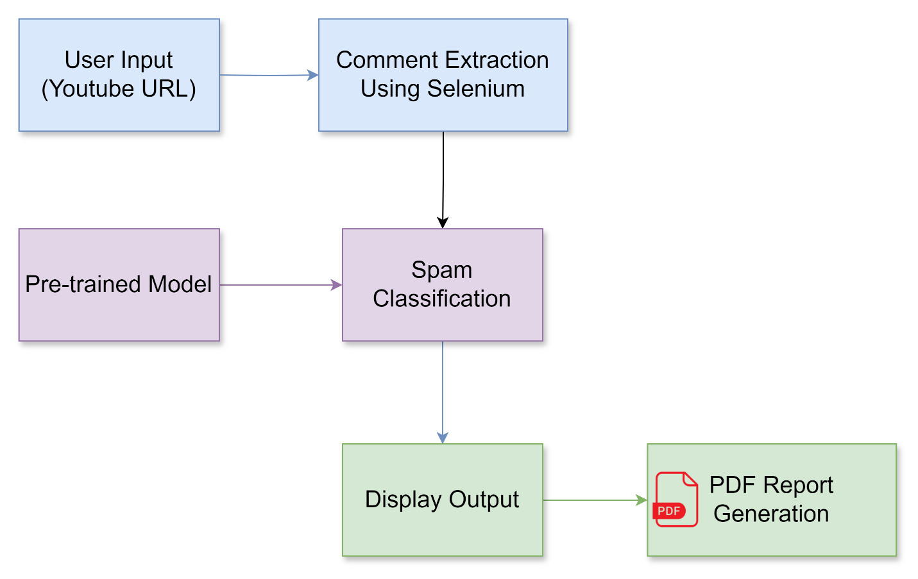

The block diagram you provided represents the workflow of your web application designed to detect spam comments on YouTube videos. Here's a breakdown of the components and their interactions:

**Data Flow:**

The arrows in the diagram depict the flow of data throughout the application. Here's the sequence:

* Users enter a YouTube video URL in the User Input section.
* This URL is passed to the Selenium Engine, which interacts with the YouTube website and extracts comments from the specified video.
* The extracted comments are then fed into the pre-trained Machine Learning Model.
* The model analyzes each comment and assigns a classification (spam or legitimate) along with an accuracy score.
* The classified comments with their labels and scores are displayed in the Output section for the user to review.

Overall, the block diagram provides a clear visual representation of how your web application leverages Selenium and a pre-trained machine learning model to identify and categorize spam comments within YouTube video comment sections.

* 1. **MODEL OVERVIEW**

**Components:**

* **User Input (URL):** This block represents the starting point where users interact with the application. It allows users to enter the URL of a YouTube video they want to analyze for spam comments.
* **Comment Extraction:** This block represents the process of retrieving comments from the YouTube video using Selenium. It signifies the steps Selenium takes to navigate the web page, locate the comment section, and collect the comment text for each entry.
* **Pre-trained Model:** This block represents a pre-trained model you've chosen for spam classification. This model has already been trained on a large dataset of labeled comments (spam and legitimate) and can analyze text to predict its category.
* **Spam Classification:** This block depicts the core functionality of the application. The extracted comments are fed into the pre-trained model, which analyzes each comment and assigns a classification (spam or legitimate) based on its learned patterns. The model also generates an accuracy score indicating its confidence level in the prediction.
* **Classified Comments as Output:** This block represents the final results presented to the user. It showcases the extracted comments alongside their corresponding classifications (spam or legitimate) and the accuracy scores provided by the model.
* **PDF Report Generation:** This block represents the functionality where users can select comments, they believe are spam and generate a PDF report. This report would likely include details like the video information (URL, title, channel name), the flagged comments with their classifications, and timestamps of PDF generated for reference.
  + 1. **User Input (URL)**

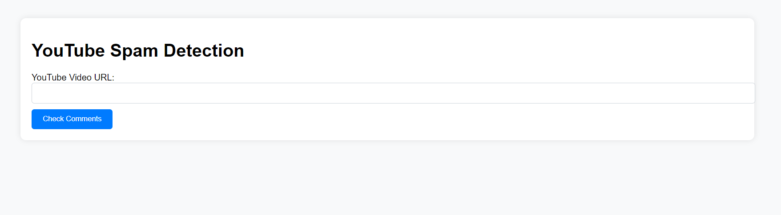

This module acts as the starting point for your spam analysis. Just by providing the URL of the YouTube video, it starts to investigate. The application needs to know which video to focus on to analyze the comments within that specific section.

* + 1. **Comment Extraction**

This module serves as the foundation for the comment analysis process. It leverages a powerful web automation tool called Selenium to retrieve comments from the target YouTube video. Here's a breakdown of its operation:

* **URL Validation:** The initial step involves the validation of the user-provided URL. Our system employs robust validation techniques to ensure the URL points to a legitimate YouTube video. This safeguards against potential errors and ensures the subsequent extraction process targets the correct content.
* **Selenium Invocation:** Following successful URL validation, Selenium is invoked. Selenium acts as a skilled web navigator, utilizing the validated URL to navigate to the specific YouTube video page. This ensures the extraction process focuses on the intended comments section.
* **Dynamic Content Handling:** Modern web pages often employ dynamic content loading techniques. Our system acknowledges this and incorporates strategies to handle such dynamic elements. This ensures that even comments loaded asynchronously after the initial page load are successfully captured by Selenium.
* **Comment Section Identification:** Upon reaching the video page, Selenium employs advanced element locators to precisely identify the designated comment section. These locators are designed to be adaptable and resilient to potential layout variations across different YouTube videos. This ensures consistent comment extraction regardless of the video's specific design.
* **Comment Text Extraction:** Once the comment section is pinpointed, Selenium meticulously extracts the text content of each individual comment within that section. This process may involve navigating through paginated comment sections if the video has a large number of comments. The extracted comments are then meticulously formatted and prepared for further analysis.
* **Data Delivery:** Finally, the collected comment text data is delivered as a structured dataset to the subsequent stage of the process. This dataset serves as the raw material for the machine learning engine, which will analyze each comment to identify potential spam content.

By operating efficiently behind the scenes, this module lays the groundwork for a comprehensive comment analysis experience. It ensures the retrieval of the necessary data (comments) from the target YouTube video, paving the way for a more informed and insightful user experience.

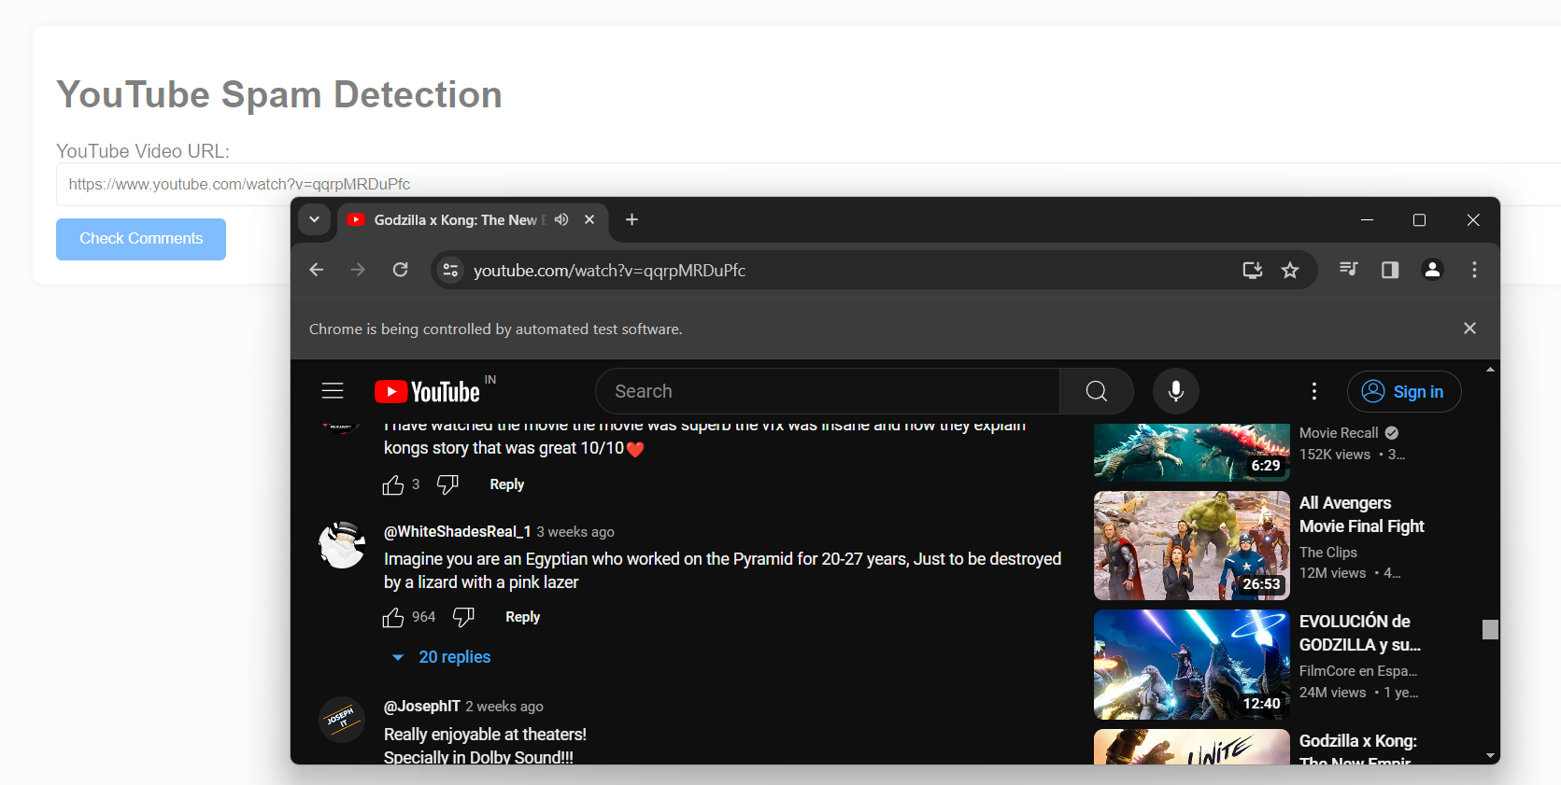

* + 1. **Pre-trained Model**

This module represents the core of our comment analysis system - a pre-trained machine learning model. Think of it as a highly skilled analyst with a wealth of experience in identifying spam content. Here's a closer look at its functionality:

* **Standing on the Shoulders of Giants:** We didn't build this model from scratch! Extensive research has been conducted on YouTube spam detection. Building upon this valuable foundation, we've explored a wide range of machine learning algorithms, including Decision Tree, Logistic Regression, Random Forest, Support Vector Machine, and Extra Tree Classifier. Additionally, we've delved into the power of ensemble models, which combine the strengths of multiple algorithms like Ensemble with Hard Voting and Ensemble with Soft Voting. Through a series of classification experiments, we've meticulously evaluated the performance of each approach.
* **Choosing the Champion:** Based on the results of our experiments, we've selected a pre-trained model that demonstrates exceptional accuracy in distinguishing spam comments from legitimate discussions. This model has been meticulously trained on a vast dataset of labeled comments, allowing it to recognize the subtle patterns and characteristics that define spam content.
* **Expert Analysis:** Once comments are extracted from the target YouTube video, they're presented to this pre-trained model. The model then analyzes each comment individually, leveraging its acquired knowledge to predict the likelihood of it being spam. This analysis process is akin to a skilled professional meticulously examining evidence to reach a conclusion.

By incorporating this powerful pre-trained model, our system strives to provide a more nuanced understanding of the comment section associated with any YouTube video you choose to analyze.

* + 1. **Spam Classification**

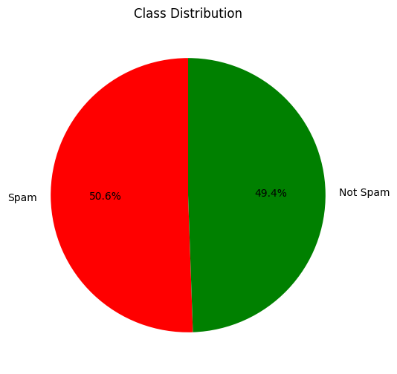

This module represents the heart of the application's functionality. Extracted comments from the target YouTube video are fed into a pre-trained machine learning model. This model acts as a sophisticated classifier, having been meticulously trained on a vast dataset of labeled comments. Through this training, the model has learned to identify subtle patterns and characteristics that distinguish spam content from legitimate discussions. As each comment is presented to the model, it undergoes a rigorous analysis process. The model leverages its acquired knowledge to predict the likelihood of the comment being spam and assigns a corresponding classification (spam or legitimate). Additionally, the model generates an accuracy score for each prediction, indicating its confidence level in the classification. This score provides valuable insight into the certainty of the model's analysis. By employing this powerful central analysis engine, the application is able to deliver a comprehensive understanding of the comment section associated with any YouTube video you choose to analyze.

* + 1. **Classified Comments as Output**

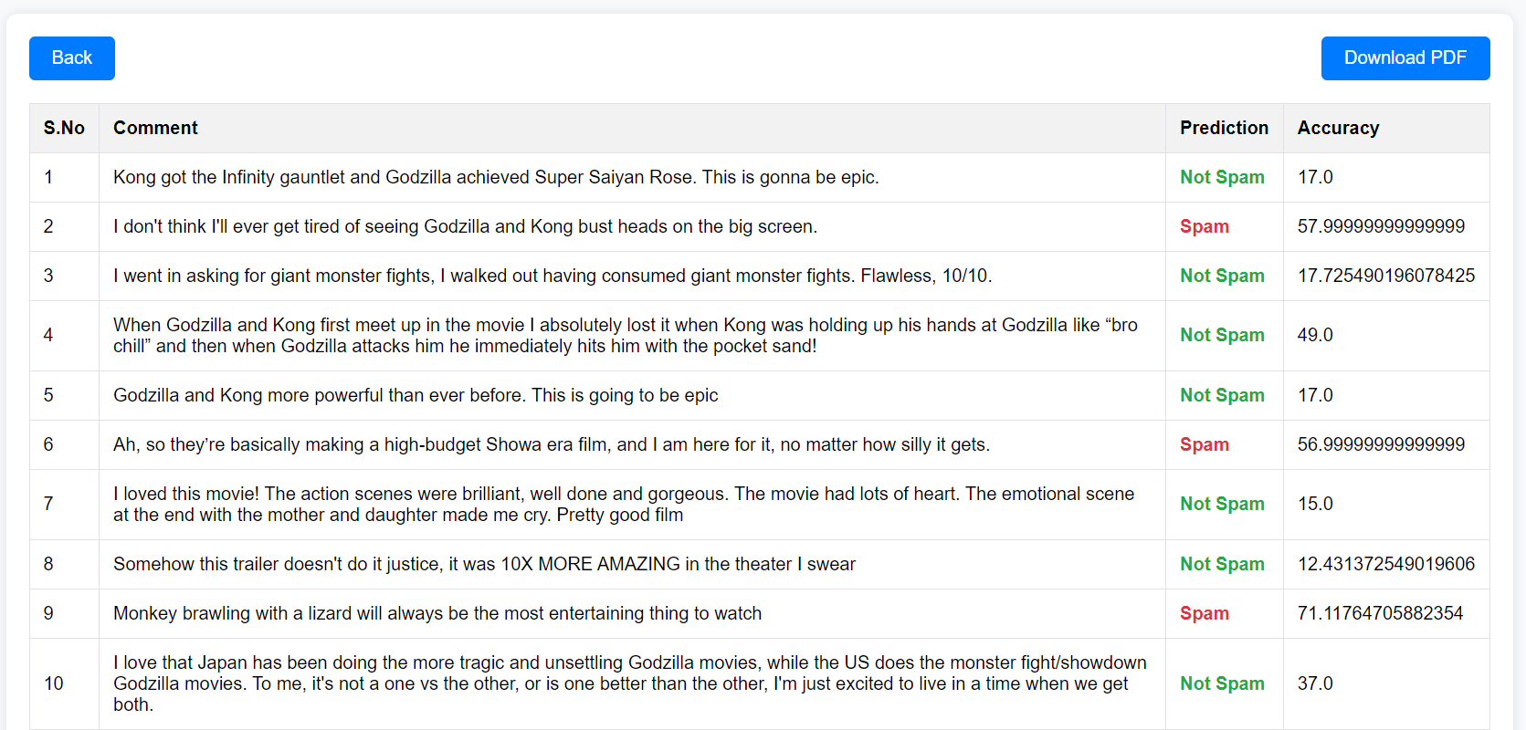

This module delivers the analysis results in a user-friendly format. Extracted comments appear alongside their classifications (spam or legitimate) and corresponding accuracy scores. These scores indicate the model’s confidence in each prediction, helping you gauge the potential for false positives or negatives. This clear presentation empowers you to grasp the comment section’s content, identify potential spam, and form an informed opinion about the overall discussion.

* + 1. **PDF Report Generation**

The final step provides a clear picture of the comment section. An automatically generated PDF report details the video information (URL, title, channel name), along with all extracted comments and their corresponding classifications (spam or legitimate) with accuracy scores. This timestamped report allows you to review the analysis, understand the comment section’s makeup, and potentially share it with the video creator if needed, contributing to a more positive and informative YouTube experience for everyone.

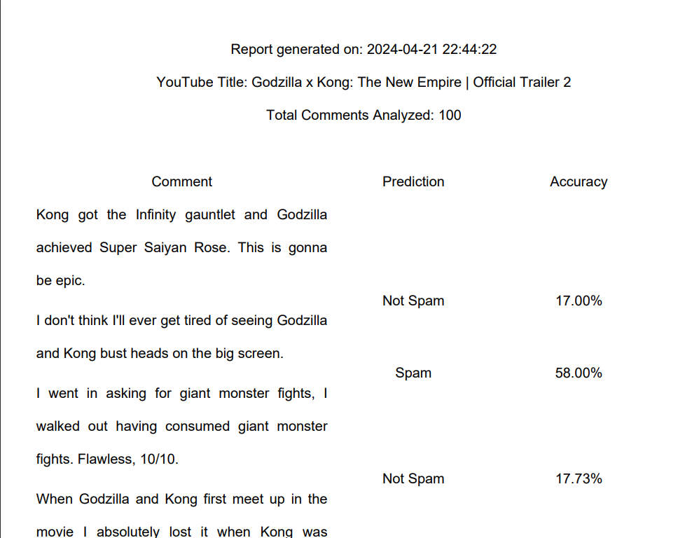

**CHAPTER 5**

**IMPLEMENTATION**

* 1. **TECHNOLOGIES USED**

The YouTube spam detection System utilizes a combination of technologies to ensure robust functionality and a seamless user experience:

* + 1. **WEB TECHNOLOGIES**

The front-end serves as the user's primary point of interaction with the application. Leveraging a combination of HTML, CSS, and JavaScript, it delivers a visually appealing and intuitive experience.

* HTML: The Foundation: HTML acts as the foundational layer, defining the core structure and layout of the web page. Imagine it as a blueprint for the user interface, outlining the placement of elements like headings, and buttons.
* CSS: Shaping the Aesthetics: CSS takes the blueprint provided by HTML and breathes life into it with visual styles. It controls aspects like font size, color schemes, and element positioning, ensuring a professional and user-friendly presentation.
* JavaScript: Interactive Engagement: JavaScript adds a layer of interactivity to the user interface. It empowers the application to respond to user actions and dynamically update content. JavaScript likely plays a crucial role in:
  + Potentially displaying a loading indicator or message while the application is working behind the scenes to fetch comments and perform analysis.
  + Dynamically populating the web page with the analysis results received from the Python back-end. This might involve displaying details like video information, extracted comments, classifications (spam or legitimate), and accuracy scores.
  + Pagination for Extensive Datasets: A critical function of JavaScript involves implementing pagination to handle large volumes of comments. This ensures the user interface doesn't become overwhelmed with information. JavaScript can dynamically create multiple pages, allowing users to navigate through the comment analysis results in a clear and organized manner.

**Seamless Collaboration:** The back-end, built with Python, handles the core functionalities of data processing and analysis. The front-end, meticulously crafted with HTML, CSS, and JavaScript, acts as the communication bridge, translating user interactions into actionable requests for the back-end and presenting the analysis results in a clear and informative manner. This seamless collaboration between the front-end and back-end ensures a user-centric and efficient application experience.

* + 1. **PANDAS**

Pandas, a powerful Python library, acts as your data maestro. It transforms the raw comments into a meticulously organized DataFrame - a two-dimensional table similar to a spreadsheet. Each comment occupies a row, with its details in designated columns. This structured format streamlines data exploration and manipulation, laying the foundation for machine learning analysis.

* + 1. **NLP**

The Natural Language Toolkit (NLTK) serves as a comprehensive suite of libraries within the Python ecosystem, specifically designed for tasks involving human languages. The NLTK plays a role in enriching the text preprocessing stage:

* **Stop Word Removal:** NLTK provides pre-built stop word lists encompassing common words like "the," "a," or "an" that hold minimal meaning for sentiment analysis. Downloading these stop words using allows you to efficiently remove them from the comments, ensuring the machine learning model focuses on the content that truly matters. This step contributes to a more focused and accurate analysis.
* **Stemming and Lemmatization:** NLTK also offers functionalities for stemming (reducing words to their base form) or lemmatization (reducing words to their dictionary form). While not explicitly mentioned in the imports, downloading resources like WordNet can potentially enable these tasks. Stemming and lemmatization can further enhance the analysis by ensuring that words with similar meanings are treated consistently, improving the model's ability to identify patterns within the comments.

By leveraging NLTK's capabilities, the groundwork for a more nuanced understanding of the comments extracted from YouTube videos.

* + 1. **SCIKIT-LEARN**

Scikit-learn is a cornerstone library in Python for various machine learning tasks. It provides a versatile toolkit that can be applied to a broad range of problems.

* **Data Preprocessing (Train-Test Splitting):** The train_test_split function is crucial for model evaluation. It meticulously splits data into training and testing sets. The training set is used to teach the model, while the testing set assesses its generalizability on unseen data. This helps ensure the model learns underlying patterns and isn't simply memorizing the training data.
* **Feature Engineering (Text Vectorization):** The CountVectorizer acts as a bridge between textual data and machine learning models. It transforms textual content (like comments) into numerical representations based on word frequency. This allows models, which work with numbers, to understand the comments and extract features for classification tasks.
* **Model Selection and Training:** Scikit-learn offers a variety of classification algorithms, including those you've imported: **Extra Trees Classifier**, **Random Forest Classifier**, **Decision Tree Classifier**, **Logistic Regression**, and **Support Vector Machine**. You can efficiently train these models on the preprocessed data. Imagine feeding comments to each model, allowing it to learn the patterns that distinguish different categories (e.g., spam vs. legitimate comments).
* **Model Evaluation (Cross-Validation and Performance Metrics):** Scikit-learn goes beyond just training models. It provides tools for robust evaluation using techniques like StratifiedShuffleSplit for cross-validation and metrics like accuracy_score and classification_report. Cross-validation rigorously assesses the model's performance across different data splits, providing a more reliable estimate of its generalizability. The classification_report offers a comprehensive view of the model's performance through metrics like precision, recall, and F1-score, helping identify strengths and weaknesses of each candidate model.

By leveraging Scikit-learn's comprehensive toolkit, you establish a systematic approach to machine learning model selection and evaluation for various classification tasks. This ensures you choose the most effective model for the problem at hand.

* + 1. **JOBLIB**

In machine learning, retraining models can be time-consuming. joblib.dump from the joblib library offers a solution. It efficiently saves (dumps) your trained model as a file, preserving its learned information. This translates to faster analysis for new data, smoother integration into applications, and easier sharing for collaboration. In essence, joblib.dump captures your model's knowledge for future use.

* + 1. **MATPLOTLIB**

Matplotlib reigns supreme as a fundamental Python library for creating static, animated, and interactive visualizations. It offers a comprehensive set of tools for plotting various data types, including line charts, scatter plots, histograms, and more. Pyplot serves as a convenient submodule within Matplotlib, providing a MATLAB-like interface for plotting. It streamlines the process by offering a collection of functions that manage figure creation, plotting elements, and overall layout. This makes it easier to create basic to moderately complex visualizations without delving into the intricacies of Matplotlib's object-oriented API.

* + 1. **SELENIUM**

Selenium transcends the realm of a simple web scraping tool. It establishes itself as a robust web automation framework. Imagine having a conductor overseeing a web browser, meticulously controlling its actions. Selenium empowers you to:

* **Navigate with Precision:**You can program Selenium to navigate web pages just like a human user would, following links, opening new tabs, and adhering to complex website structures.
* **Interact with Web Elements:**Selenium can simulate user interactions like filling out forms, clicking buttons, and selecting options. This allows you to automate tasks that would otherwise be manual and time-consuming.
* **Extract Data Strategically:**Selenium can be used to strategically extract data from websites. Imagine it carefully selecting and retrieving specific content elements like text, images, or product information. This empowers large-scale data collection for analysis or integration into other applications.

Applications Beyond Scraping: While web scraping is a prominent use case, Selenium's capabilities extend beyond that. It's valuable for automated web application testing, ensuring functionality across different browsers and scenarios. Additionally, it can be used for UI (user interface) automation tasks, streamlining repetitive interactions within web applications.

* + 1. **FLASK**

Within the Python ecosystem, Flask carves a niche as a minimalist web framework. It prioritizes simplicity and flexibility, empowering developers to construct web applications with agility. Here are the hallmarks that distinguish Flask:

* Concise Core Functionalities: Flask shuns the "kitchen sink" approach, offering a well-defined core set of features for routing, request handling, and templating. This streamlined approach fosters rapid prototyping and clear application structure.
* Extensible Architecture: Flask embraces modularity. It readily integrates with a vast array of third-party extensions, enabling developers to seamlessly incorporate functionalities like database interactions, user authentication, or sophisticated templating engines. This empowers customization without requiring developers to reinvent the wheel.
* Performance Optimization: Flask's lightweight nature translates to efficient application performance. This makes it a compelling choice for scenarios where resource constraints are a concern or when rapid response times are essential.

In essence, Flask caters to developers who value efficient development cycles, clear code structure, and the flexibility to tailor functionalities through extensions. This combination positions Flask as a prominent choice for building web applications in Python, particularly for projects that prioritize agility and performance.

* + 1. **PDF GENERATOR**

The ability to generate PDF reports is a valuable asset for data analysis projects. Python offers various approaches to achieve this:

* **Third-Party Libraries:** A rich ecosystem of third-party libraries empowers developers to create professional-looking PDF reports with ease. Popular options like FPDF. These libraries provide a structured API for defining document layout, adding text, images, and tables, and customizing formatting elements like fonts and margins.
* **Custom Function Development:** For intricate formatting requirements or highly specialized report structures, developers can opt to create custom Python functions leveraging lower-level libraries like PyPDF2 or Cairo. This approach grants maximum control over the report's appearance and behavior but necessitates a deeper understanding of PDF file structures and formatting techniques.
* Leveraging Third-Party Libraries: A rich tapestry of third-party libraries empowers developers to construct professional-looking PDF reports with agility and efficiency. Popular FPDF offer well-defined APIs for:
  + Structured Document Layout: Precise control over the organization of elements within the PDF report, ensuring a clear and visually appealing presentation.
  + Rich Content Inclusion: Seamless integration of textual content, images, and tables to comprehensively convey analysis results and insights.
  + Formatting Customization: Granular control over visual elements like fonts, margins, and text alignment, enabling developers to tailor the report's aesthetics to specific requirements.
* Custom Function Development: For scenarios demanding highly specialized report structures or intricate formatting needs, developers can embark on creating custom Python functions. This approach leverages lower-level libraries like PyPDF2 or Cairo, granting maximum control over every aspect of the report's appearance and behavior. However, it necessitates a deeper understanding of PDF file structures and formatting techniques.

Regardless of the chosen method, PDF generation in Python empowers you to effectively communicate analysis results and share insights in a clear, concise, and portable format that can be easily reviewed and distributed.

* 1. **DATA SETS**

Within the realm of machine learning, datasets reign supreme as the foundational element for analysis, model development, and the extraction of valuable insights. Imagine them as meticulously curated collections of data points, akin to well-structured spreadsheets. Each data point can encompass a variety of elements such as text, numerical values, or images, meticulously tailored to the specific problem at hand.

The structure and content of a dataset are intricately linked to the underlying data type it represents and the ultimate objective of the analysis. For instance, a dataset employed for YouTube comment spam classification might contain textual comments extracted from YouTube videos, along with labels indicating whether each comment is spam or legitimate. In this case, the features would be the words within the comments, and the target labels would be "spam" or "legitimate."

To harness the full potential of machine learning, datasets are strategically divided into three distinct subsets:

* **Training Dataset: The Instructor's Guide:** The training dataset serves as the cornerstone upon which a machine learning model is built. It's the portion of data meticulously selected to train or instruct the model. Imagine it as a comprehensive textbook, painstakingly crafted to equip the model with the knowledge necessary to perform its task effectively. The training data consists of input-output pairs, where the input represents the features or attributes the model should learn from (e.g., words in a YouTube comment), and the output represents the corresponding target or label (e.g., "spam" or "legitimate"). The model meticulously analyzes these input-output pairs, identifying patterns and relationships within the data. By iteratively adjusting its internal parameters based on these learnings, the model progressively hones its ability to recognize patterns and make predictions on new comments.
* **Validation Dataset: The Fine-Tuning Tool:** The validation dataset plays a critical role in preventing a common pitfall in machine learning: overfitting. Overfitting occurs when a model becomes overly fixated on the specific patterns within the training data, hindering its ability to generalize effectively to unseen data (e.g., new YouTube comments). The validation dataset acts as a separate benchmark used to periodically evaluate the model's performance during the training phase. This allows you to fine-tune the model's hyperparameters, which are essentially the settings that control its learning process. By analyzing the model's performance on the validation dataset, you can make informed decisions about adjustments like the learning rate or the model's architecture (e.g., number of layers in a neural network), ensuring it learns effectively without becoming overly reliant on the training data.
* **Test Dataset: The Final Examination:** The test dataset serves as the ultimate assessment of a machine learning model's generalizability. It's a completely separate set of data that the model has never encountered during training or validation. This ensures an unbiased assessment of the model's ability to perform well on new, unseen data, such as comments on YouTube videos from channels it has not seen before. Imagine it as the final exam that truly gauges the model's understanding and its readiness for real-world application. By analyzing the model's performance on the test dataset, you gain valuable insights into its strengths and weaknesses, allowing you to determine its suitability for the task of classifying YouTube comments as spam or legitimate.

In essence, datasets are the fuel that powers machine learning models. By carefully constructing and utilizing YouTube comment datasets, you empower your models to learn from the nuances of human language used in online video comments, make accurate predictions about whether a comment is spam or legitimate, and ultimately, contribute to a cleaner and more informative YouTube experience. This structured approach ensures that machine learning models are built upon a robust foundation, enabling them to deliver reliable and generalizable results.

**SAMPLE DATASET**

Datasets are used in the form of csv here.

|  |  |  |  |  |
| --- | --- | --- | --- | --- |
| **COMMENT_ID** | **AUTHOR** | **DATE** | **CONTENT** | **CLASS** |
| **e7xj2zkrq5e85mwz** | James Miller | 2013-12-21T02:26:48 | Unlock premium content! <https://bit>.ly/hvu1hj Limited stock available! Untrustworthy Follow me on social media! | 1 |
| io7ngg5o8bq8z648 | Alexander Martinez | 2013-11-19T05:20:07 | Amazing video! Check out my other videos! | 0 |
| 5dw3kdx2upj9jtpe | Sophia Garcia | 2013-12-05T20:51:36 | Be your own boss! <https://tinyurl>.com/3n5nfh Offer expires soon! Spam Claim your reward now! | 1 |
| 1be8l3fzfpxl525o | Sophia Jones | 2013-11-17T23:06:10 | I’m impressed! Don’t forget to share with your friends! | 0 |
| gr1c9nu3o2p3g1jm | James Rodriguez | 2013-11-28T19:07:33 | I learned a lot from this video. Help me reach 1 million subscribers! | 0 |
| ojwnebh2td74qfil | Michael Brown | 2013-12-24T20:16:53 | Great content! Limited time offer! | 0 |
| cyt2cr744g9frjea | William Smith | 2013-12-15T21:21:15 | Double your income now! <https://is>.gd/oxe1lv Check it out now! Follow me on social media! | 1 |
| tjk88x0dbljjqodv | Ava Jones | 2013-11-30T01:44:18 | Click here for free stuff! <https://is>.gd/rb6h1c Check it out now! Virus Hit the notification bell! | 1 |

**CHAPTER 6**

**RESULTS AND DISCUSSION**

Evaluating the efficacy of your YouTube comment spam classification model transcends a singular metric. A comprehensive approach that considers various performance indicators is crucial for gaining a nuanced understanding of the model's strengths and weaknesses. Here are some key metrics to incorporate:

**Classification Accuracy:**

Accuracy is a fundamental metric that reflects the overall correctness of your machine learning model. It's calculated as the ratio of correctly classified comments (both spam and legitimate) to the total number of comments in the test dataset.

**CHAPTER 7**

**CONCLUSION**

In conclusion, YouTube comment spam disrupts user experience and hinders meaningful discussions. Automated comment classification offers a promising solution to tackle this challenge. It examined related studies on YouTube spam comment screening and conducted classification experiments with Five different machine learning techniques (Decision Tree, Logistic Regression, Random Forest, Support Vector Machine, Extra Tree Classifier). By leveraging machine learning and meticulously curated datasets, comment classification systems can be trained to distinguish between legitimate comments and spam with high accuracy. A well-tuned model can significantly reduce spam while minimizing the misclassification of legitimate comments. This fosters a cleaner and more productive online environment for users to engage with video content and participate in constructive conversations.

* 1. **PORJECT ACHIEVEMENT**

The deluge of spam comments on YouTube videos can significantly hinder user engagement and discourage meaningful discussions. Automated comment classification systems have emerged as a powerful tool to combat this issue. These systems leverage machine learning techniques and meticulously curated datasets to achieve substantial progress in accurately classifying comments as either legitimate or spam. Through meticulous model refinement and performance optimization, researchers have demonstrably improved spam detection rates while minimizing the misclassification of legitimate comments. This paves the way for a more positive user experience on YouTube, fostering a more constructive and engaging online environment.

* **Cleans Up Comments**
* **Improves User Experience**
* **Protects Users**
* **Boosts Engagement**
* **Automates Moderation**
  1. **CHALLENGES FACED**
     1. **CHALLENGES FACED IN MODEL TRAINING**

**Data Quality and Labeling** -Spam comments can be cleverly disguised or use slang terms, making it difficult to accurately label them in the training data. The quality and quantity of your training data directly affect the model's ability to learn and generalize effectively. An insufficient dataset or poorly labeled data can lead to inaccurate classifications.

**Evolving Nature of Spam** -Spammers continuously develop new tactics and techniques to bypass detection. The model needs to be adaptable enough to learn and identify new forms of spam as they emerge.

**Context and Nuance** -Human language can be subtle and filled with sarcasm or humor. The model needs to be able to distinguish between genuine comments and those that might appear spammy but are intended to be funny or ironic.

**Class Imbalance** -Legitimate comments often far outnumber spam comments. This imbalance can lead the model to prioritize identifying the more frequent class (legitimate comments) and neglect learning the nuances of spam effectively.

**Computational Resources** -Training complex machine learning models, especially for large datasets, can require significant computing power and time.

* + 1. **CHALLENGES FACED IN FETCHING COMMETNS**

**Pagination and Incremental Loading:** Comments on YouTube videos are often paginated, requiring iteratively fetching additional comment sections to access all content. Additionally, YouTube might employ lazy loading, where comments are loaded progressively as the user scrolls down the page, further complicating complete extraction.

**Data Incompleteness:** Scraped data might not always encompass the entirety of a comment. Essential details like timestamps, usernames, or profile pictures might be absent due to the way YouTube structures and delivers comment information.

**Responsible Scraping Practices:** Ethical considerations are paramount when scraping YouTube comments. Respecting rate limits and avoiding overwhelming YouTube's servers is crucial. Additionally, it's essential to adhere to YouTube's Terms of Service, ensuring no private user information is collected or stored without explicit consent.

**Ethical Considerations:**

* **Privacy:** Transparency is key regarding data collection and anonymization practices for comments used to train the model.
* **Bias:** Balanced training datasets are crucial to prevent the model from unfairly targeting certain types of comments.
* **Free Speech:** Safeguards are needed to prevent legitimate comments from being flagged as spam in the name of filtering harmful content.
* **Misuse:** The technology should be used responsibly to avoid potential misuse for suppressing voices or manipulating online conversations.
  + 1. **OVERCOMING CHALLENGE**

**Tricky Data** -Train with human-labeled data and explore techniques like data augmentation to tackle disguised spam and limited datasets.

**Evolving Spam** -Continuously learn from new data to stay ahead of spammers' ever-changing tactics.

**Context Confusion** - Use advanced NLP techniques to understand comment intent and avoid flagging sarcastic or humorous comments.

**Class Imbalance** - Balance your training data by oversampling rare spam comments or under sampling frequent legitimate ones.

**Computing Crunch** - Train in the cloud or optimize your model to reduce its computational footprint.

* 1. **FUTURE WORK**

While the proposed approach demonstrates promising results in tackling YouTube comment spam, there's always room for advancement. Here are some key areas for future exploration:

* **Multilingual Detection:** Expanding the model's capabilities to encompass a broader range of languages would significantly enhance its global impact. This would necessitate the incorporation of multilingual datasets and potentially exploring language-agnostic or transfer learning techniques.
* **Advanced Contextual Understanding:** By leveraging advancements in Natural Language Processing (NLP), the model could be further refined to grasp the nuances of human language. This includes effectively identifying sarcasm, humor, and cultural references within comments, leading to more accurate spam classification and mitigating the risk of misclassifying legitimate content.
* **Explainable AI Integration:** Implementing Explainable AI (XAI) techniques would provide valuable insights into the model's decision-making process. This would foster trust and transparency, allowing for targeted improvements and model refinement based on user feedback and evolving comment trends.
* **User-Centric Feedback Mechanisms:** Establishing user feedback loops would allow the model to continually learn and adapt. This could involve incorporating user reports or sentiment analysis of flagged comments, enabling the model to adjust its classification strategies over time based on real-world user preferences.

By steadily pursuing these future directions, researchers can develop even more robust and effective YouTube comment spam detection systems. This dedication to continuous improvement will ensure a cleaner and more enjoyable online experience for users worldwide, fostering a more productive and constructive environment for online video discussions.